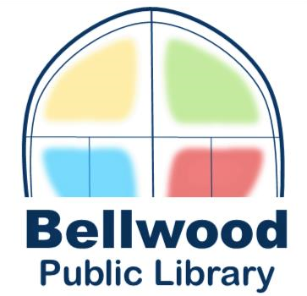

# SPECIAL BOARD

Monday, August 25, 2025 at 5:30PM

Bellwood Public Library

600 Bohland Avenue,

Bellwood IL 60104

# NOTICE

**NOTICE** is hereby given that the **Board of Trustees for the Bellwood Public Library** will hold a **SPECIAL MEETING** on **Monday, August 25, 2025 at 5:30 p.m.** at the **Bellwood Public Library, 600 Bohland Avenue, Bellwood, IL 60104,** to consider the following:

**AGENDA**

**1. Call to Order**

# 2. Roll Call

1. **Public Comment** (limit to 3 minutes per person)
2. **Closed Session**—pursuant to **5 ILCS 120/2(c)(3)** of the **Illinois Open Meeting Act** for the selection of a person to fill a public office, as defined by this Act, including a vacancy in a public office, when the public body is given power to appoint under law or ordinance.
3. **Appointment to Fill Vacancy on the Board of Trustees**
4. **Public Comment** (limit to 3 minutes per person)

# 7. Adjournment